Carleton University
School of Computer Science
COMP 3005B
Database Management Systems
Winter 2019

Instructor:
Mengchi Liu
mengchi@scs.carleton.ca
HP 5364

Lectures: Monday and Wednesday: 11:35-12:55 HS 1301

Office Hours: Wednesday: 1:00-2:30 or by appointment

Teaching Assistants:
- Liu Chen <liuchen@cmail.carleton.ca>
Office Hours: Monday 3:00-5:00 HP5353
- Nooshin Nokhanji < NooshinNokhanji@cmail.carleton.ca>
Office Hours: Tuesday 3:00-5:00 HP4125
- Norbert Eke < NooshinNokhanji@cmail.carleton.ca>
Office Hours: Wednesday 3:00-5:00 HP4125
- Dongmei Yu < DongmeiYu@cmail.carleton.ca>
Office Hours: Thursday 3:00-5:00 HP4125
- Ali Davoudian <alidavoudian@cmail.carleton.ca>
Office Hours: Friday 3:00-5:00 HP5353
TA office hours start on January 21 (Monday).
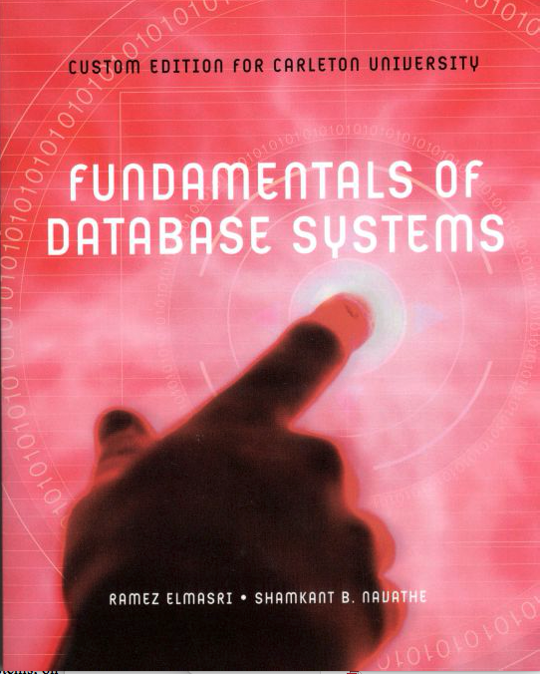
Textbook:
- Ramez Elmasri and Shamkant B. Navathe: Fundamentals of Database Systems. Seventh Edition, Pearson, 2016. Custom Edition for Carleton University (highly recommended)

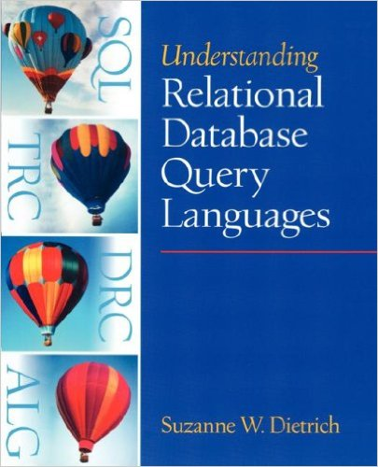
- Suzanne W. Dietrich: Understanding Relational Query Languages. Prentice Hall, 2001 (optional)

Prerequisites:
COMP 1805 or MATH 1800, plus COMP 2402 or (SYSC 2004 and 2100)

Course Information:
All important information, such as announcements, assignments, solutions, lecture notes, marks, and TA hours, will be available in culearn. It is the student's responsibility to check for new information.
Course Description:
Introduces students to concepts of database management systems, data models, database languages, database design and physical data organization. Materials:
- Overview of DB
- Databases, users, data models, database systems (Chapters 1,2)
- Relational model and query languages (Chapters 5,6,7,8)
- ER, EER models and normalization (Chapters 3,4,9,14,15)
- Database programing techniques (Chapter 10)
- Transaction processing, concurrency control and recovery (Chapters 20,21,22)

Attendance
Class attendance is extremely important, as students will be responsible for all items discussed in class.

Marking Scheme:
Assignments (5) | 25%
Midterm (Feb 25 in class) | 25%
Final (Centrally Scheduled) | 50%

Note：
- Collaborating on assignments is strictly disallowed. If found, all students involved will be given a mark of 0 and the case will be reported to the office of the Dean of Science. If you need help, please see a TA or the instructor during their office hours.
- Posting assignment solutions on discussion boards before the due date and time is prohibited and the student involved will be given a mark of 0 for the assignment.
- Assignments must be submitted to culearn in order to be marked. Assignments are allowed to be submitted one day late with 10% penalty. After one day, no submission will be accepted. Never email any assignment to me or TAs!
- Any issues regarding assignment and midterm marks should be brought to the attention of the TA who marked it (only if the TA does not address the problem to your satisfaction should you bring the matter to the instructor). This should be done no later than two weeks after the marks of this assignment/midterm are posted. After this time, no remarking will be done.
- Students must have at least 45% for the final to pass the course.

Undergraduate Academic Advisor
The Undergraduate Advisor for the School of Computer Science is available in Room 5302C HP, by telephone at 520-2600, ext. 4364 or by email at undergraduate_advisor@scs.carleton.ca. The undergraduate advisor can assist with information about prerequisites and preclusions, course substitutions or equivalencies, understanding your academic audit and the remaining requirements for graduation. The undergraduate advisor will also refer students to appropriate resources such as the Science Student Success Centre, Learning Support Services and the Writing Tutorial Services.
University Policies
Student Academic Integrity Policy. Every student should be familiar with the Carleton University student academic integrity policy. A student found in violation of academic integrity standards may be awarded penalties which range from a reprimand to receiving a grade of F in the course or even being expelled from the program or University. Some examples of offences are: plagiarism and unauthorized co-operation or collaboration. Information on this policy may be found in the Undergraduate Calendar.
Plagiarism. As defined by Senate, "plagiarism is presenting, whether intentional or not, the ideas, expression of ideas or work of others as one's own". Such reported offences will be reviewed by the office of the Dean of Science.

Unauthorized Co-operation or Collaboration. Senate policy states that "to ensure fairness and equity in assessment of term work, students shall not co-operate or collaborate in the completion of an academic assignment, in whole or in part, when the instructor has indicated that the assignment is to be completed on an individual basis". Please refer to the course outline statement or the instructor concerning this issue.
Academic Accommodations for Students with Disabilities. The Paul Menton Centre for Students with Disabilities (PMC) provides services to students with Learning Disabilities (LD), psychiatric/mental health disabilities, Attention Deficit Hyperactivity Disorder (ADHD),
Autism Spectrum Disorders (ASD), chronic medical conditions, and impairments in mobility, hearing, and vision. If you have a disability requiring academic accommodations in this course, please contact PMC at
613-520-6608 or pmc@carleton.ca for a formal evaluation. If you are already registered with the PMC, contact your PMC coordinator to send me your Letter of Accommodation at the beginning of the term, and no later than two weeks before the first in-class scheduled test or exam requiring accommodation (if applicable). After requesting accommodation from PMC, meet with me to ensure accommodation arrangements are made. Please consult the PMC website for the deadline to request accommodations
for the formally-scheduled exam (if applicable) at http://www2.carleton.ca/pmc/new-and-current-students/dates-and-deadlines
Religious Obligation. Write to me with any requests for academic accommodation during the first two weeks of class, or as soon as possible after the need for accommodation is known to exist. For more details visit the Equity Services website: http://www2.carleton.ca/equity/

Pregnancy Obligation. Write to me with any requests for academic accommodation during the first two weeks of class, or as soon as possible after the need for accommodation is known to exist. For more details visit the Equity Services website: http://www2.carleton.ca/equity/

Medical Certificate. The following is a link to the official medical certificate accepted by Carleton University for the deferral of final examinations or assignments in undergraduate courses. To access the form, please go to http://www.carleton.ca/registrar/form

